**CONTENT**

|  |  |  |
| --- | --- | --- |
| **S.No.** | **CONTENT** | **PAGE No.** |
| 1. | Abstract | 2 |
| 2. | Project Overview | 3 |
| 3. | System Design | 4 |
| 4. | Input Design | 8 |
| 5. | Output Design | 8 |
| 6. | Menu Level Description | 9 |
| 7. | Process Specification | 10 |
| 8. | Screen Layouts | 11 |
| 9. | Conclusion | 13 |
| 10. | Bibliography | 14 |

**ABSTRACT**

# The Online Voting System is a web-based platform designed to simplify and streamline the process of voting for elections, surveys, and polls. This system aims to replace traditional paper-based voting systems with a secure, user-friendly, and efficient digital solution, which ensures increased accessibility, real-time results, and better management.

# The system allows users to participate in elections, cast their votes securely, and view results as soon as the voting period ends. Through an intuitive interface, users can vote for their preferred candidate or option, and administrators can manage the election setup, monitor progress, and view voting statistics in real time.

# The system implements necessary validation to ensure that all voters make valid selections and that all necessary fields are filled. The voting process begins with a simple form where users select their preferred candidate and submit their vote. The system prevents voting without selection and provides an error message to users if they attempt to submit an incomplete form.

# As soon as the vote is cast, the system displays the results, including the total number of votes for each candidate and a countdown timer indicating how much time is left for voting.

# Additionally, the system ensures transparency by offering a real-time display of voting statistics and maintaining an audit trail of all user actions. A key feature of the platform is that it automatically locks the voting process once the voting period ends, displaying a "Voting time is up!" message.

# This enhances the integrity of the voting process, ensuring no further votes can be cast once the allotted time has expired.

# INTRODUCTION

### PROJECT OVERVIEW

## The Online Voting System is a fully automated, web-based platform designed to facilitate secure and efficient elections and voting processes. This system has been developed to meet the increasing need for an accessible and transparent method of voting for a wide range of users, whether it’s for elections, surveys, or polls.

## The system provides users with an easy-to-use interface where they can select their candidate or choice, submit their vote, and receive confirmation once the vote is successfully cast.

## The platform uses modern web technologies to ensure that users can securely vote from any device connected to the internet. It incorporates a built-in mechanism for validation and error handling, prompting users to select a candidate or option before submitting their vote.

## For administrators, the system offers an intuitive dashboard that shows real-time statistics such as the number of votes cast, vote counts per candidate, and the remaining time until voting ends. Administrators also have the ability to configure the election process, manage candidates, and generate final results.

## The system leverages a time-based mechanism for voting, displaying a countdown timer to create urgency and ensure that voting occurs within a designated window. Once the voting period is over, the system automatically locks the vote submission and displays a message informing users that the voting time has ended.

## This system ensures fairness, accuracy, and real-time reporting, making it a reliable tool for both public and private sector elections.

## 2. SYSTEM DESIGN

### 2.1 INTRODUCTION

System design is the process of defining the architecture, components, modules, interfaces, and data structures that collectively fulfill the specified requirements of a software system. It represents the transition from understanding what a system needs to do (as identified in system analysis) to figuring out how to achieve those requirements in a structured and efficient manner. While system analysis answers the “what is” question, system design addresses the “how to” aspect of building or improving a system.

This phase plays a critical role in shaping the success of the project. It involves not only outlining technical solutions but also ensuring that these solutions align with the operational and strategic goals of the organization. System design takes the recommendations from the feasibility study and converts them into a comprehensive blueprint for development, laying the groundwork for the implementation phase.

Before diving into system design, careful planning is essential. It is important to conduct a thorough analysis of the existing system—understanding its limitations, inefficiencies, and pain points—to identify how the new or upgraded system can bring about measurable improvements. This involves evaluating how the integration of computing technologies can enhance overall performance, reduce manual effort, and streamline workflows.

The significance of system design lies in its impact on quality. Design is where the foundation for high-quality software is built. A well-crafted design not only meets user requirements but also ensures maintainability, scalability, security, and efficiency of the system. It acts as a communication bridge between the end-users and the developers by transforming user-oriented documentation into technical specifications that can be interpreted and implemented by programmers, database administrators, and system architects.

Moreover, system design is both a technical and creative endeavor. It demands a blend of analytical thinking, problem-solving, and innovation to architect a solution that is technically feasible, economically viable, and user-friendly. It also includes considering user interfaces, data flows, control logic, and hardware-software integration, all of which contribute to a system that is robust, adaptable, and efficient in meeting its intended purpose.

In summary, system design is not just a step in the development cycle—it is the foundation of a successful and sustainable software product. A strong design ensures that the final system is reliable, efficient, and tailored to meet user expectations and institutional objectives.

### 2.2 INPUT DESIGN

**1. User (Voter):**

* **Voting Form:**
  + **Full Name**: Voter's full name (text input).
  + **Email**: Voter's email address (email input).
  + **Phone Number**: 10-digit contact number (numeric input).
  + **Candidate/Option**: The candidate or option the voter selects (dropdown/list of candidates).
  + **Voting Event**: The specific election or poll the voter is participating in (dropdown/text input).
  + **Age**: Voter's age (numeric input, with age validation based on voting eligibility).
* **Validation:**
  + All fields are mandatory.
  + Phone number must be exactly 10 digits.
  + Email must follow a valid email format.
  + Candidate/Option must be selected from the dropdown.
  + Age must be validated to ensure the voter is eligible to vote for the given event.

### 2.3 OUTPUT DESIGN

### 1. Voter Outputs:

### Voting Confirmation:

### Popup: On successful submission, a popup appears: “Vote submitted successfully.”

### Redirection: The user is redirected to a confirmation page or remains on the dashboard displaying their voting status.

### Vote Status:

### After admin review, the status of the vote is displayed as:

### Pending

### Approved

### Rejected

### Error Feedback:

### If required fields are missing or invalid, error messages are shown next to specific fields.

### Form submission is prevented until corrections are made.

### 2. Administrator Outputs:

### Vote Review:

### Displays a real-time list of all votes cast, including:

### Voter Name

### Selected Candidate/Option

### Vote Event

### Vote Status (Pending/Approved/Rejected)

### Action buttons (Approve/Reject)

### Dashboard Overview:

### Displays metrics such as:

### Total Number of Votes Cast

### Number of Votes Approved

### Number of Votes Pending/Rejected

### Voting Event Management:

### Displays all active voting events with details such as:

### Event Title

### Date and Time

### Voting Status (Active/Closed)

### Action buttons (Edit/Close)

### Error Feedback:

### If there are issues with the vote or voting event, error messages are displayed to guide the admin in resolving the issue before proceeding.

### This structure ensures that both voters and administrators can efficiently interact with the system, providing a transparent, secure, and seamless voting experience.

## 3. SYSTEM DEVELOPMENT

### 3.1 MENU LEVEL DESCRIPTION

###### 1. Login Menu:

###### Homepage:

###### The main landing page for users (voters and administrators) to enter their login credentials.

###### Fields: Username and Password.

###### Authentication Result:

###### On successful login, the user is redirected to the appropriate dashboard based on their role (Voter or Admin).

###### On login failure, an error popup is displayed indicating incorrect credentials.

###### 2. Voter Menu:

###### Voter Dashboard:

###### Displays a list of active voting events or polls.

###### Each voting event entry includes:

###### Voting event name.

###### Candidate/option list.

###### Voting status (open or closed).

###### Vote button.

###### Voting Form:

###### Allows the voter to submit their vote.

###### Fields include:

###### Name (pre-filled based on login).

###### Email (pre-filled based on login).

###### Selected candidate/option.

###### Includes a "Submit Vote" button to complete the voting process.

###### Form Validation ensures the voter selects a candidate/option before submitting the vote.

###### 3. Admin Menu:

###### Admin Dashboard:

###### Displays an overview of all ongoing and completed voting events with real-time results.

###### Metrics include:

###### Total number of active votes.

###### Total number of voters.

###### Number of votes for each candidate/option.

###### Voting Event Management:

###### Allows administrators to create and manage voting events.

###### Fields include:

###### Voting event title.

###### Voting options (candidates).

###### Start and end time for voting.

###### Voting event status (active or closed).

###### Buttons: Create Event / Update Event / Close Event.

###### Vote Management:

###### Displays a list of all votes submitted.

###### Each entry includes:

###### Voter’s name.

###### Voted candidate/option.

###### Voting event name.

###### Voting time.

###### Voting Results:

###### The admin can view real-time voting results for each voting event.

###### Results include:

###### Candidate/option names.

###### Total number of votes.

###### Vote percentage for each candidate/option.

###### 4. System Access Control:

###### Voter Access:

###### Voters can submit their votes, view results for open voting events, and track their voting status.

###### Admin Access:

###### Administrators can manage voting events, view and manage voter registrations, and oversee real-time results and data.

###### Unauthorized Access:

###### Non-registered users (e.g., non-authenticated individuals) are prevented from accessing the voting system or casting votes.

###### 5. Voting Time Control:

###### Step 1:

###### Each voting event is configured with a start and end time.

###### The system automatically locks the voting process once the time is over.

###### Step 2:

###### The system sends notifications to voters when the voting event is about to close.

###### After the voting period ends, the system automatically finalizes the results and prevents further voting.

###### 6. System Maintenance and Scalability:

###### Step 1:

###### The system supports future enhancements such as:

###### Adding new types of voting events (e.g., multiple-choice, ranked voting).

###### Real-time notifications for new voting events or updates.

###### Step 2:

###### Future features could include:

###### Integration with secure voting systems such as blockchain for integrity.

###### Mobile app support for easy access and voting.

###### Support for more complex voting types (e.g., ranked-choice voting).

###### Analytics for administrators to review voting patterns, demographics, and engagement.

###### This structure ensures that both voters and administrators can effectively manage and participate in voting events, providing a secure and efficient online voting experience.

### 3.2 PROCESS SPECIFICATION

The Online Voting System is a secure, user-friendly web application designed to automate and streamline the entire voting process for elections, polls, and surveys. It ensures system accuracy, data security, and scalability, making it an ideal solution for a variety of voting events.

**1. Vote Submission**

**Step 1:**

* The voter accesses the voting page and selects their preferred candidate or option.
* Fields include:
  + Candidate options (e.g., Alice, Bob, Charlie).
  + Submit Vote button.

**Step 2:**

* The system performs validation to ensure:
  + A candidate or option has been selected.
  + Validation is done to ensure no votes are cast unless the voter selects a candidate.

**Step 3:**

* Upon successful validation, the vote is recorded in the system.
  + Success Popup: "Vote submitted successfully."
  + The system then redirects the voter to the confirmation page with a message displaying the status of their vote submission.

**2. Vote Status Display (Voter View)**

**Step 1:**

* Upon login, the voter is redirected to the Voting Dashboard.

**Step 2:**

* The system displays available candidates or options, allowing the voter to view the voting results in real-time.
  + Candidate names.
  + Number of votes each candidate has received.

**Step 3:**

* The voter can submit their vote by selecting their preferred option and clicking the "Submit Vote" button.

**3. Voting Results (Admin View)**

**Step 1:**

* The administrator accesses the Admin Dashboard to view and manage all voting submissions.

**Step 2:**

* The system retrieves and displays all votes in a tabular format, including:
  + Candidate names.
  + Number of votes each candidate has received.
  + Total votes cast.

**Step 3:**

* The administrator can monitor the voting process in real-time, ensuring all votes are captured correctly and that no discrepancies are found.

**Step 4:**

* Once the voting time is completed, the system locks the voting process and displays the results automatically.

**4. Voting Time Control**

**Step 1:**

* The system is configured to set a time limit for voting.
  + This is typically defined by the event organizer.

**Step 2:**

* As the voting period expires, the system automatically closes the voting mechanism.
  + The system notifies all voters with a popup message: "Voting time is up!"

**Step 3:**

* After the voting window ends, the administrator is notified, and results are displayed for all users to view.

**5. User Authentication & Access Control**

**Step 1:**

* Only authenticated users (voters and administrators) can access the system.
  + Voters can submit their vote and view the status of their vote.
  + Administrators can manage the voting process, monitor votes, and generate results.

**Step 2:**

* Unauthorized users (e.g., non-registered individuals) are restricted from accessing any features or voting data in the system.

**6. System Scalability and Future Enhancements**

**Step 1:**

* The system supports future enhancements such as:
  + Integration with mobile apps for remote voting.
  + Multi-language support for global users.
  + Allowing multiple elections or polls to run simultaneously.

**Step 2:**

* Future features could include:
  + Real-time analytics and detailed reports for election organizers.
  + Integration with secure blockchain technology to guarantee vote integrity.
  + Customizable voting templates for different types of elections (e.g., multiple-choice, ranked-choice).

By automating and securing the voting process, this Online Voting System enhances transparency, reduces errors, and ensures a seamless voting experience for all participants, while providing administrators with full control over the election process.

**4. SYSTEM TESTING**

**4.1 SCRREEN LAYOUTS**



Voting Form for Favorite Candidate

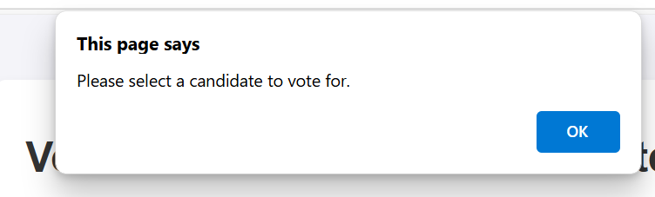

Error Message for Missing Candidate Selection

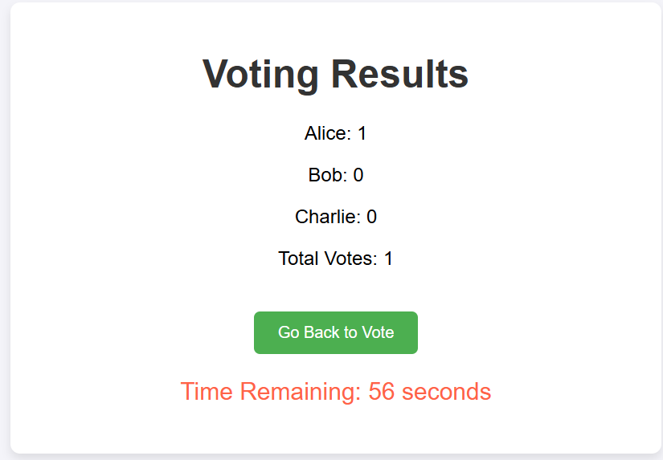

Voting Results and Countdown Timer



Voting Time Is Up Notification

## 5. CONCLUSION

## The Online Voting System offers a revolutionary approach to the voting process, improving accessibility, transparency, and efficiency. By replacing traditional paper-based systems, the platform makes voting more convenient, allowing participants to cast their votes from anywhere at any time within the designated voting window. It empowers users by giving them the flexibility to vote remotely, while also ensuring that the voting process is secure, verifiable, and free from manipulation.

## The automated nature of the system significantly reduces administrative work, eliminating the need for manual vote counting and minimizing the chance of human error. Real-time results reporting allows administrators to stay informed about the progress of the election, while also enabling voters to view up-to-date statistics. By introducing automated security checks, vote tracking, and system notifications, the Online Voting System increases the reliability of the voting process and instills confidence among users.

## The system's future potential is vast, with the possibility to integrate additional functionalities such as secure voter identity verification, advanced analytics to track voter behavior, integration with external databases, and mobile app support. These features could further streamline the process, making elections more secure, accessible, and efficient.

## In summary, the Online Voting System is a step forward in modernizing the voting process, providing a secure, reliable, and user-friendly solution for elections. It not only simplifies voting for users but also enhances the overall election management for administrators, reducing the administrative workload and increasing transparency

## 6. BIBLIOGRAPHY

1. OpenAI: "GPT-3: Language Models for Text Generation." https://[www.openai.com](http://www.openai.com/)
2. GeeksforGeeks: "Computer Science Portal." [https://www.geeksforgeeks.org](https://www.geeksforgeeks.org/)
3. YouTube: “Various Tutorials and Educational Content." https://[www.youtube.com](http://www.youtube.com/)